Scientific documentation

* Main features

The smartphone will see the traffic ahead through its camera, and then show the driver some extra information that could help him in different situations.

It must recognize:

* obstacles (people, road marks and other cars);
* the weather conditions outside
* road marks

Depending on the user’s location, car and speed, the application will show different warnings or alerts, depending on the danger level of the obstacle.

* What does the AI do in this case?
* The AI will learn to differentiate different objects in the space, and also predict behaviors that could put in danger the life of the user (eg. the car in front hits emergency breaks).
* The AI will be also responsible for understanding the weather conditions, and alert the user to prevent an accident from bad weather conditions (heavy rain, snow, etc)
* In the case of the city, the AI will recognize road signs, inform the user regarding road rules, and also warn him if the path he took was forbidden in that way.
* Related work & useful tools

Apple’s Core ML: <https://developer.apple.com/documentation/coreml>

ObjectDetection: <https://github.com/tucan9389/ObjectDetection-CoreML>

Training Object Detection Models in Create ML: <https://developer.apple.com/videos/play/wwdc2019/424/>

Pedestrians: <http://www.pedestrian-detection.com>

Routing: <http://neo.lcc.uma.es/vrp/vehicle-routing-problem/>

* How it works?

Apple released 2 powerful tools for creating and using ML model:

* CreateML can be used on MacOS (Desktop & Laptops); with CreateML we can create and train custom machine learning models. Also we can use it for improving model’s accuracy, by alternating the date we have.
* CoreML can be used on mobile platforms too (both iPhones and Apple Watches); with CoreML we can integrate previously created machine learning models into our apps. If we really want, we can improve model’s performance on device, but that usually takes a lot of time due to hardware constraints.

For this project we will use Object Detector feature to find the objects inside our image.

At this point in time, Apple doesn’t offer any details on how the Object Detector works behind the scenes. The documentation doesn’t offer many details regarding the customization or any low-level details regarding the implementation. This might change over the course of time, as it was release less than 3 years ago.

Docs:

<https://developer.apple.com/documentation/createml>

<https://developer.apple.com/documentation/coreml>

<https://apple.github.io/coremltools/coremlspecification/index.html>

Small data ( 101 images train, 80 images test)

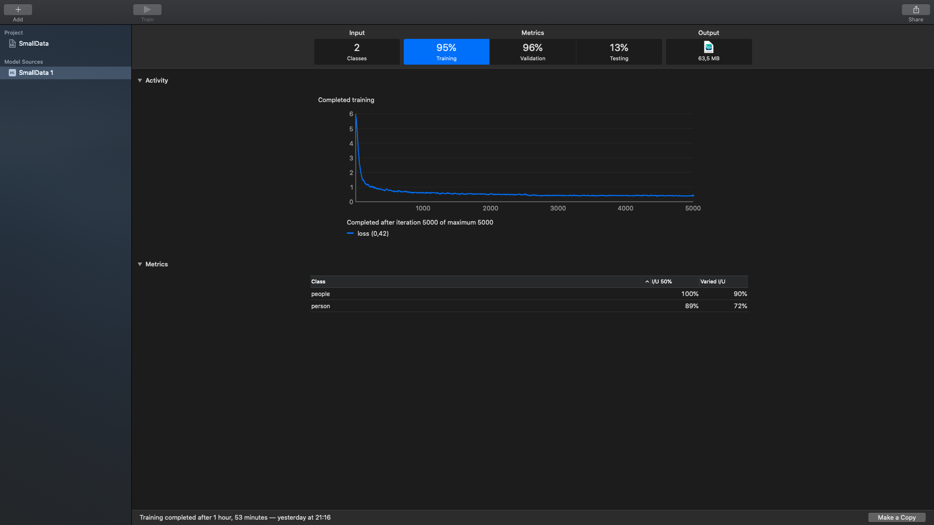

Real bench: ( 989 images train, 510 images test)

